What should I do if my eSIM activation on my iOS device gets stuck?
Sometimes, eSIM activation on an iOS device may stall. This often happens when you have an eSIM installed but haven't yet arrived in your destination country/region. Even if it displays "Activating" or "Activation failed," don't worry, the eSIM is fully installed. The activation process will complete once you arrive at your destination and are within network coverage. Below are some screenshots for reference: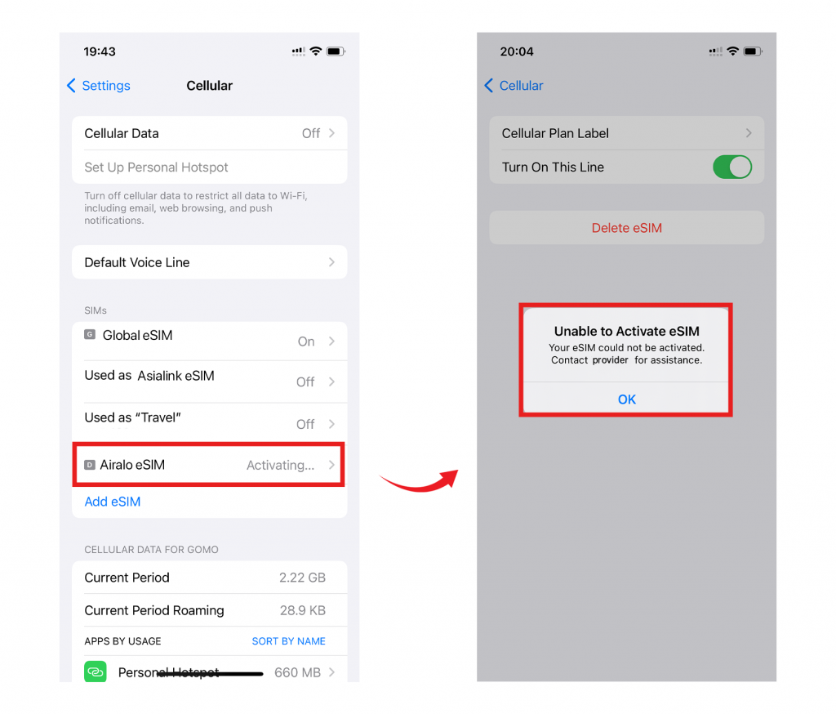Please remember that even if the eSIM activation process stalls, you can still use other features that don't rely on a network connection. Once you arrive at your destination and your device is within network coverage, the eSIM will be successfully activated, and you can start using it. If you have any questions, please feel free to contact our support team; we'd be happy to help!

